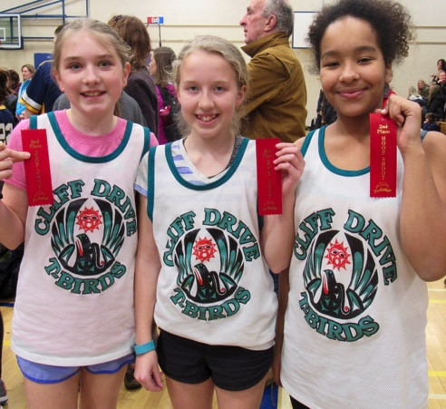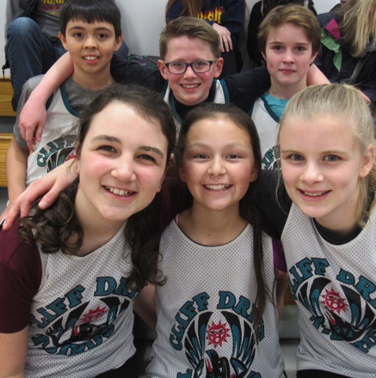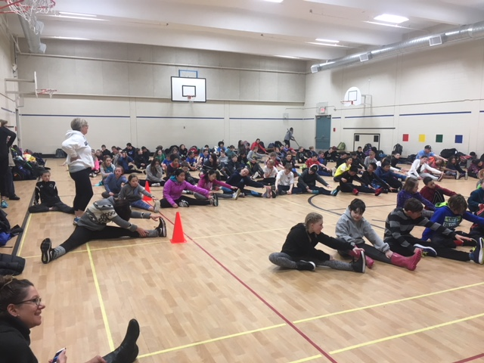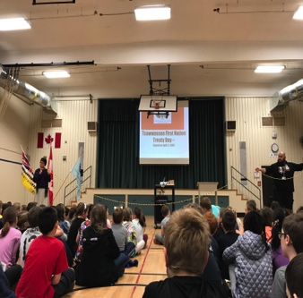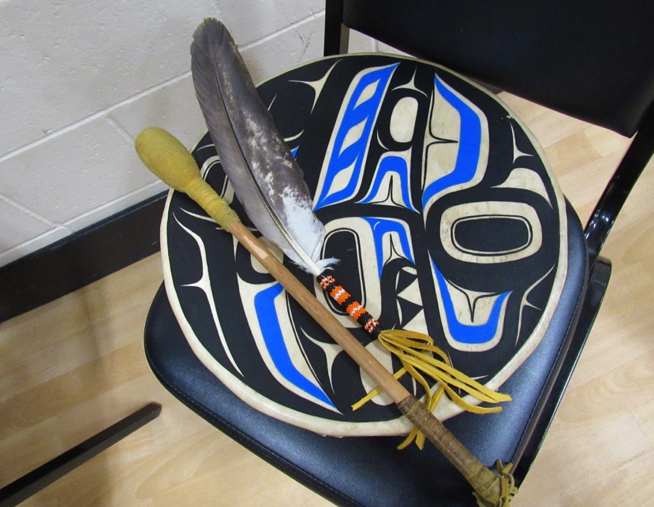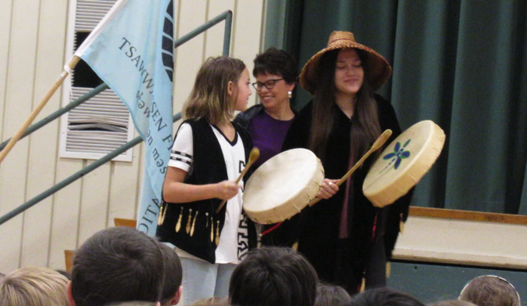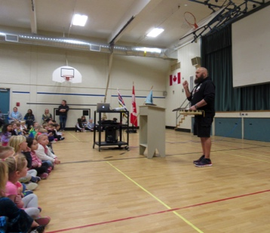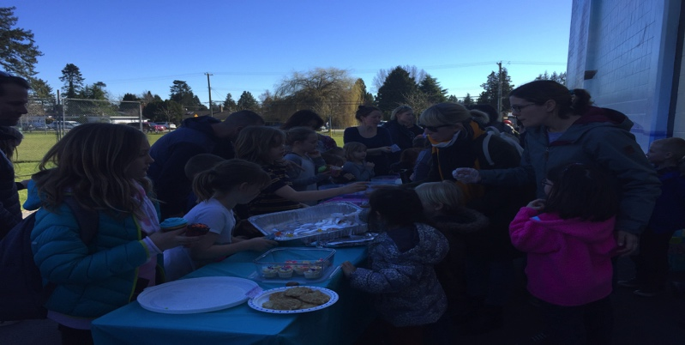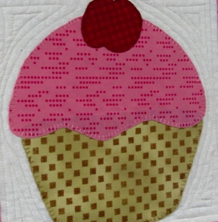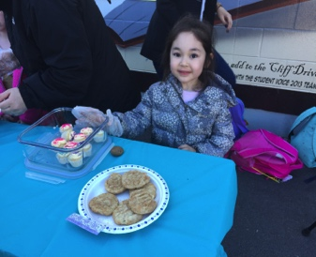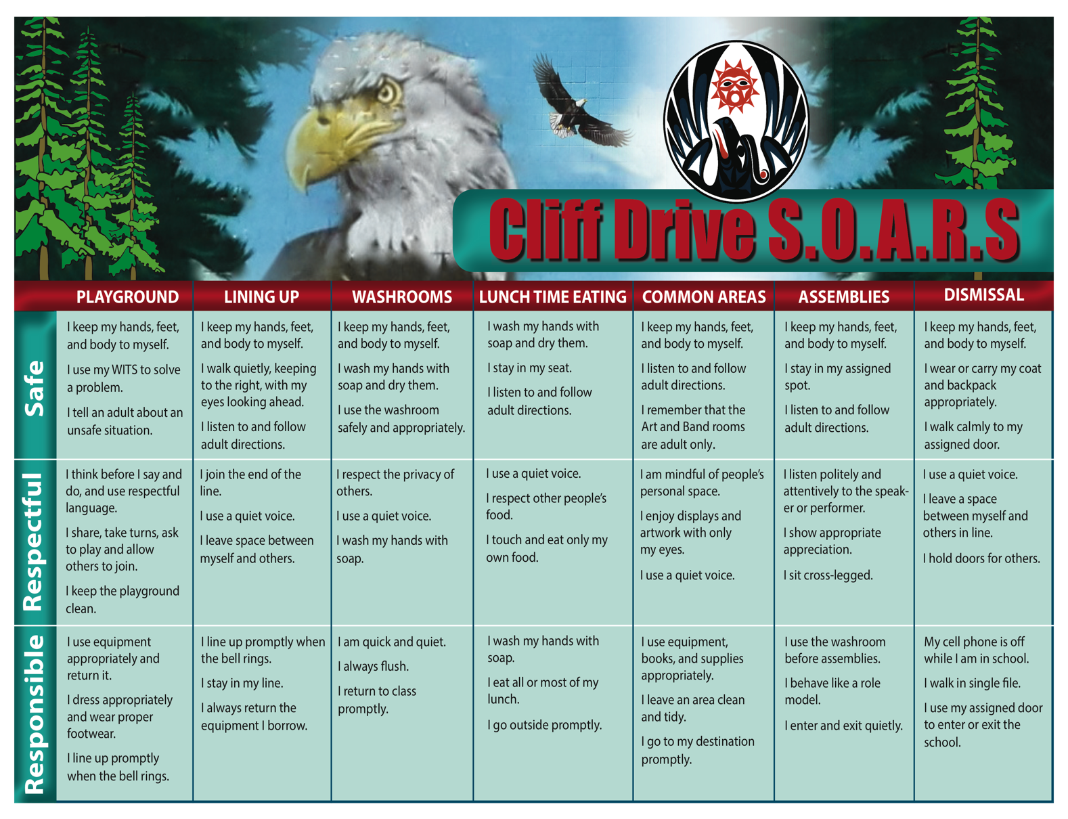

Training for Track and Field is underway! The sessions are well attended and students show great participation and school spirit. As part of our April events at Cliff Drive, intermediate students will be participating in daily outdoor track and field practices. Please help support your child by ensuring that he/she is dressed appropriately for this. A change of clothing and a pair of dry socks/footwear is also suggested.

**Informal Mini Meet (Track only)-SDSS Wednesday, May 2nd**

Beach Grove is hosting an *informal* Mini-Meet again this year at SDSS to allow our track participants an opportunity to get accustomed to the track and experience the excitement of taking part in a running event. Last year our track athletes demonstrated a high level of participation and determination. Participants meet at the track at 3:15 and start running events at 3:30. The events offered are: the Shuttle relays (Grade 4’s only), 600m/800m and the 4x100m. For this Mini-Meet, parents are required to transport their children to and from SDSS and to supervise them while at the meet. We are hopeful that most athletes are able to attend.

### Athletic News: Track & Field

Hoop Shoot 2018!

Congratulations to the teams from Cliff Drive that represented us so well at the annual Hoop Shoot finalist competition held at SDSS.

Cliff Drive Elementary

April Newsletter

Councours d’art Oratoire

Congratulations to Keira and Georgia, the Cliff Drive finalists! Well done! The girls wanted to share some insight with our school community on this great opportunity:

“We were so grateful to have the privilege to present at the District Concours d’art Oratoire. It was an amazing experience and we got to meet so many talented French students. Georgia’s paragraph was about la musique rend motivation (how music motivates you) and Keira’s presentation was about Les avontages de parler François et anglais au Canada (The benefits of speaking French and English in Canada). We really enjoyed tis experience and would love to have this same opportunity again. Merci!”

## Light It Up Blue

Cliff Drive celebrated the anniversary of the Tsawwassen First Nation Treaty in an assembly on Friday, April 6th. The TFN treaty came into effect on April 3, 2009. It's the first urban treaty in B.C. history and the first modern treaty negotiated under the B.C. Treaty Commission process.

The ‘Light It Up Blue’ campaign marks World Autism Awareness Month in April to support awareness and research to help Canadians living with autism spectrum disorder. We are inviting students to join the thousands of people across the world to wear blue on Friday, June 13th in honour of the millions of individuals and families affected by autism.

Cliff Drive Elementary has adopted PBIS, a school-wide approach to behavior expectations. PBIS is a proactive approach in which students are directly taught behavior expectations just as they are taught academic skills. Please refer to our PBIS teaching matrix. Together, we work to practice our core values of Safety, Respect and Responsibility.

# TFN Treaty

# Assembly

Here’s a list of what they were able to buy with the money:

* 1 dairy cow
* 1 goat
* A pair of chicken
* School uniforms and fees
* Sports Equipment
* Hand washing stations and access to clean water storage

Math Celebration

The Annual Math Celebration is an opportunity for our Grade 4-7 students to come together and fuel their passion for math. Students work to solve a number of problems; however, each team receives the same problem at the same time from a volunteer math adjudicator, who also observes the work. Math Celebration would not happen without teacher volunteers on staff. We are grateful to Mr. Connaughton for his organization and leadership on this event.

# Kindergarten Leadership at Cliff Drive

Congratulations to the Division 15 teachers, students and parents who raised 430.00 at their bake sale just before Spring Break! A BIG thank-you goes to all the parents and students that purchased the cupcakes in support of the fundraiser. The inspiration for this fundraiser came from a unit on community and the many different communities that we belong to, leading to discussion on the differences and similarities between our community and life in Canada and life in other countries, and how those differences can be celebrated. Following some rich discussions and a beautiful story, “Beatrice’s Goat,” which is a story about how a girl in Uganda and her family receive a goal as a gift, the students wanted to try to raise money to buy a goat for a family in another part of the world. The students were able to make the connection that this is a positive and sustainable way to help others and far surpassed their initial goal!

Earth Day

April 22

What lies behind us and what lies before us are tiny matters compared to what lies within us.

Cliff Drive Students are Learning to be Leaders

*Ralph Waldo Emerson*

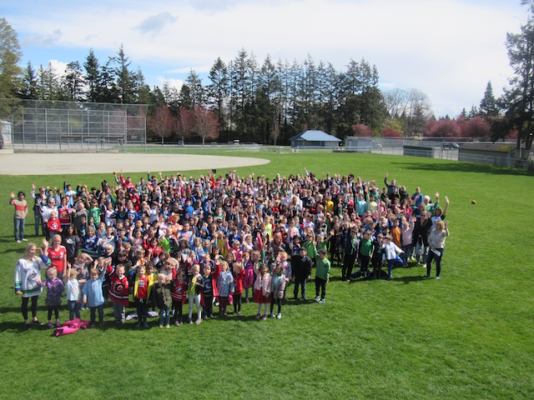 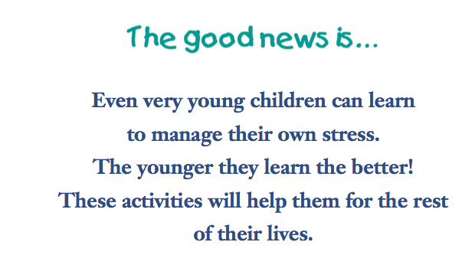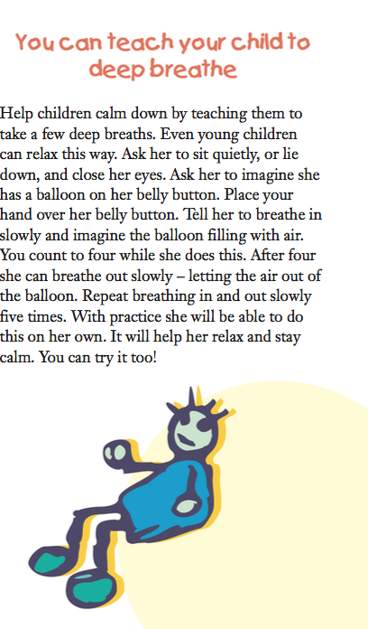

Safe Respectful Responsible

From the Desk of the Teacher Librarian

There has been a buzz of excitement in the library this week surrounding our new beanbag chairs. They are sturdy and brighten up the space. I would also like to thank Tara. H for her very generous donation that went towards refilling all four of the older beanbag chairs, and Laura S. and Jennifer W. for the many hours they put into keeping the library organized and the trollies empty.

**Spring Book Fair dates are Wednesday, May 30th to Friday June 1st (8:30-9:00 am and 3:00pm to 4:30 pm)**. If you have time to volunteer and help at the purchase desk, I would appreciate the help.

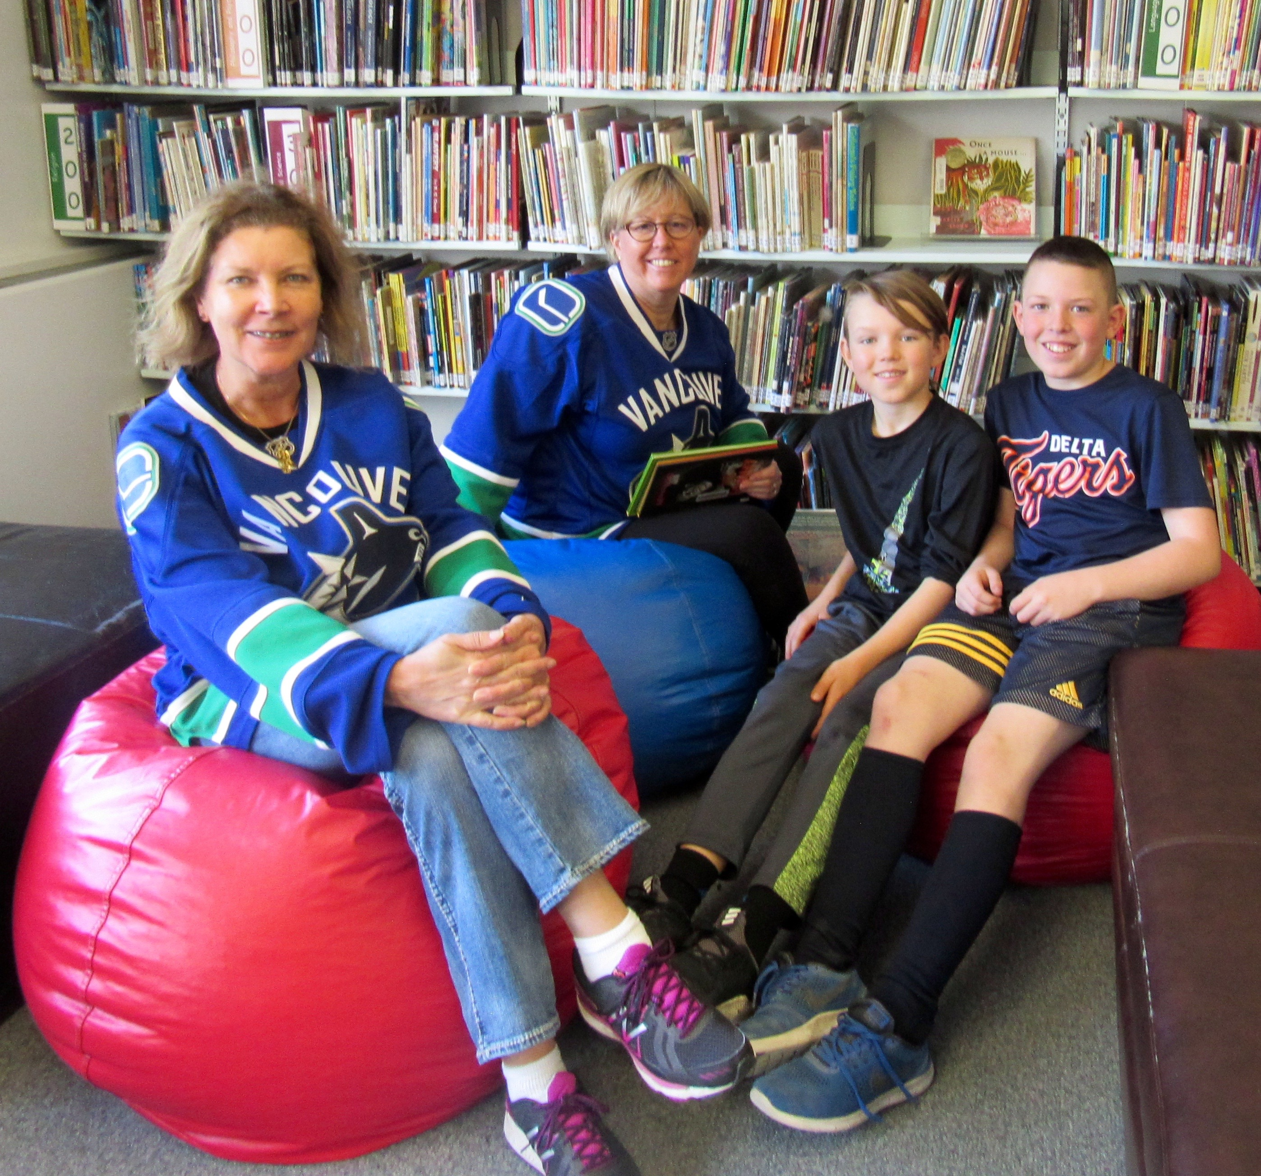

Reading Link Challenge

Reading Link Challenge is a yearly event that encourages reading as a fun recreational activity by Grade 4 and 5 students of all reading abilities to engage in the sport of reading. Interested students form teams of 6 players. Each of the teams is responsible for knowing the contents of six books. The 2017-18 titles are: “*Masterpiece,”* by Elise Broach, “*The Mask That Sang,”* by Susan Currie, “*Fish in a Tree,”* by Linda Hunt, “*After Peaches,”* by Michelle Mulder, “*The Incredible Twisting Arm,”* by Kate Egan, and “*Phineas MacGuire Erupts!”* By Frances O’Roark Dowl.